**Product Demand Prediction**

**INTRODUCTION :**

A product company plans to offer discounts on its product during the upcoming holiday season. The company wants to find the price at which its product can be a better deal compared to its competitors. For this task, the company provided a dataset of past changes in sales based on price changes. You need to train a model that can predict the demand for the product in the market with different price segments.

**DATA COLLECTION:**

The dataset that we have for this task contains data about:

1. the product id;
2. store id;
3. total price at which product was sold;
4. base price at which product was sold;
5. Units sold (quantity demanded);

**Year-wise Data Collection:**

Each year's data is organized in its separate table, and I can create separate datasets for each year. This structure allows me to analyze demand patterns, trends, and variations on a yearly basis.

In a real-world scenario, you would collect data for each year and then combine the yearly datasets to create a comprehensive dataset for your entire analysis.

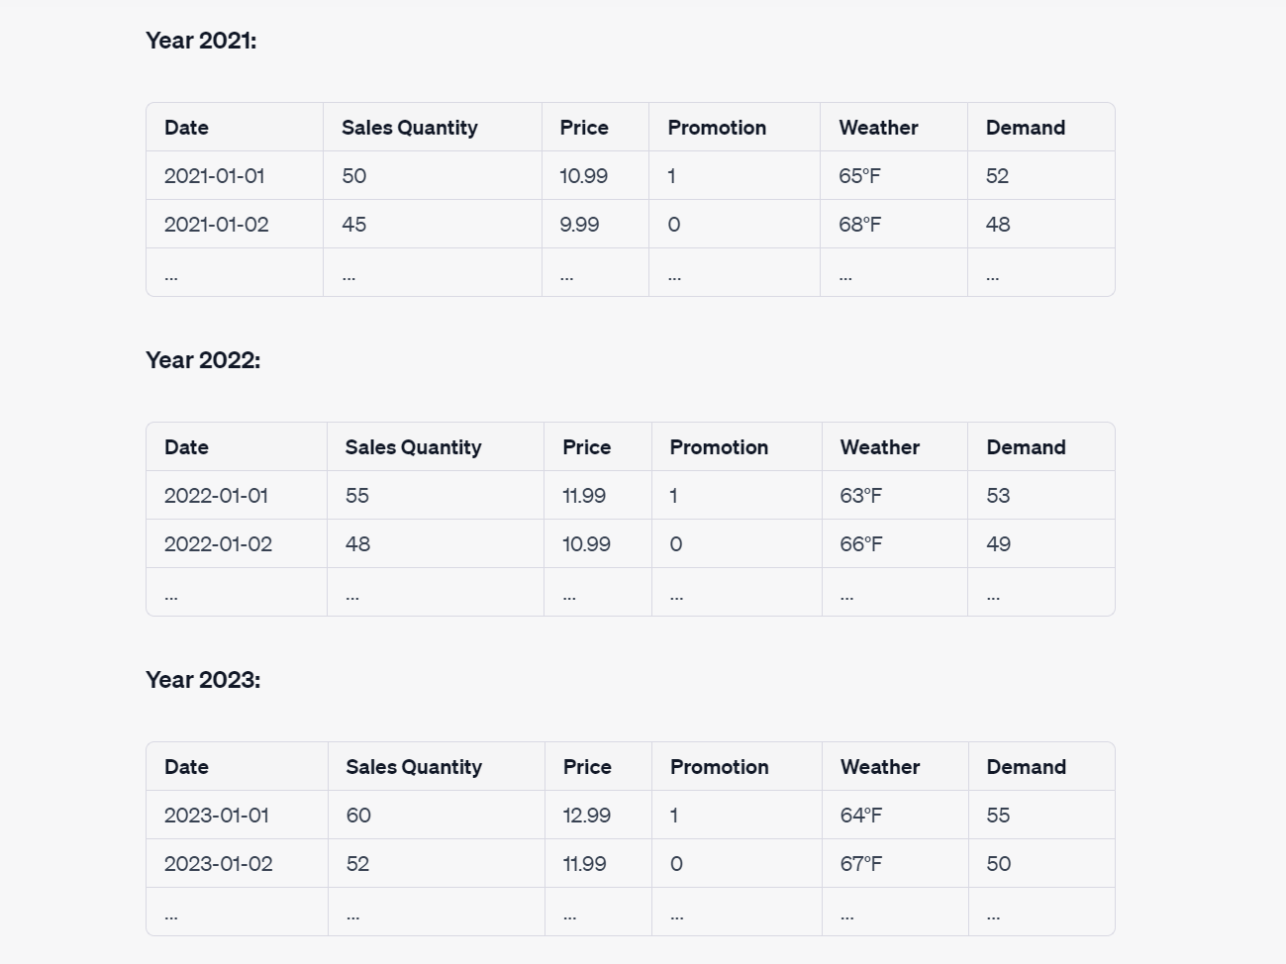

**Date:** The date when the sales occurred.

**Sales Quantity:** The number of units of the product sold on that date

**Price:** The price of the product on that date.

**Promotion:** A binary variable (0 or 1) indicating whether a promotion was running on that date.

**Weather:** An external factor, such as the daily temperature.

**Demand:** The target variable, representing the actual demand for the product on that date.

**Data Processing:**

Data processing is often an iterative and exploratory process, and the steps may vary depending on your specific dataset and the machine learning algorithms you intend to use. After processing the data, you can proceed to model selection, training, and evaluation to make predictions for product demand.Top of Form

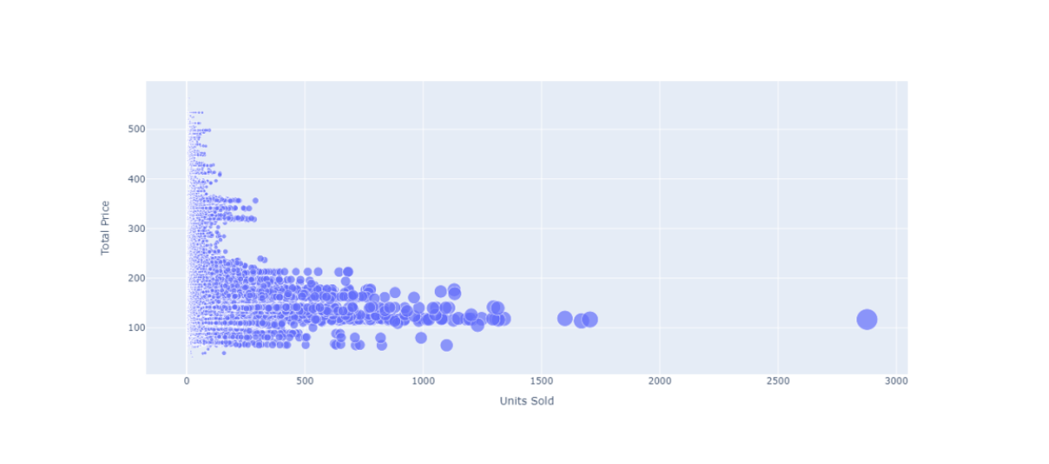

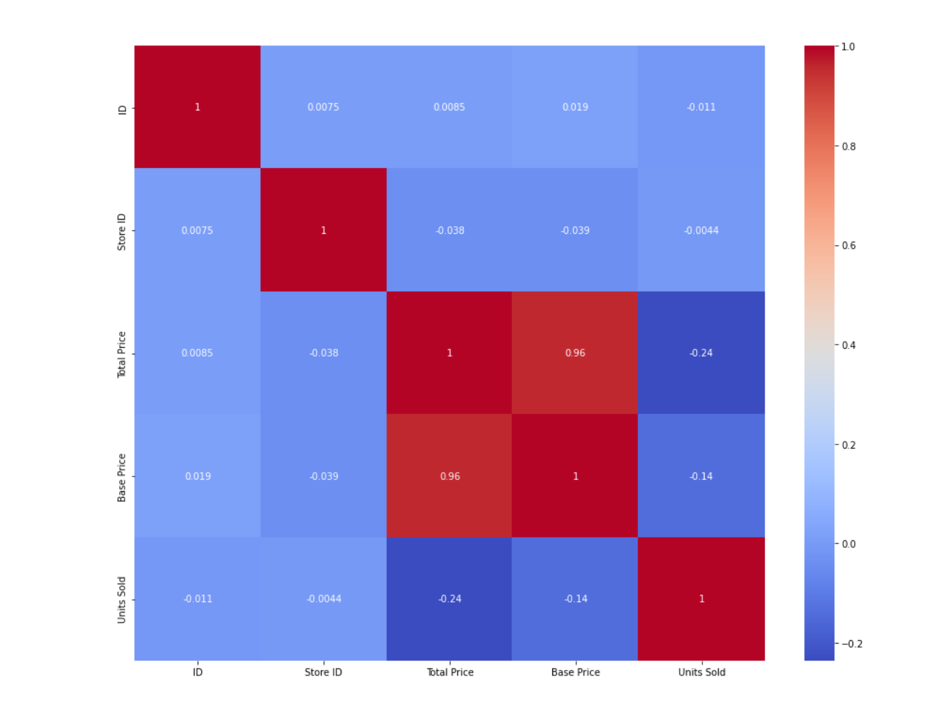

**Accuracy:**

The accuracy of a product demand prediction model can vary widely depending on the quality of your data, the features used, and the choice of machine learning algorithm. Accuracy is typically measured using various evaluation metrics, including:

**Mean Absolute Error (MAE) :** This metric measures the average absolute difference between the predicted values and the actual values. A lower MAE indicates better accuracy.

**Mean Squared Error (MSE):** MSE measures the average squared difference between predicted and actual values. It is widely used but tends to penalize larger errors more heavily.

**Root Mean Squared Error (RMSE):** RMSE is the square root of the MSE and provides a more interpretable metric that is in the same units as the target variable.

**R-squared (R2):** R-squared measures the proportion of the variance in the target variable that is predictable by the model. A higher R2 indicates better predictive accuracy.

**Forecasting Metrics (e.g., MAPE, sMAPE):** For time-series demand prediction, metrics like Mean Absolute Percentage Error (MAPE) and symmetric Mean Absolute Percentage Error (sMAPE) are commonly used to evaluate accuracy.

**CONCLUSION:**

Product demand prediction with machine learning is a powerful tool that empowers businesses to make informed decisions, optimize operations, and enhance customer satisfaction. By leveraging historical data and relevant features, machine learning models provide insights into future demand trends. While achieving perfect accuracy can be challenging, the benefits of improved decision-making, efficient supply chains, dynamic pricing, and data-driven insights make demand prediction an invaluable asset for business success. However, continuous monitoring and data refinement are essential for maintaining model effectiveness in a dynamic market environment.

Top of Form